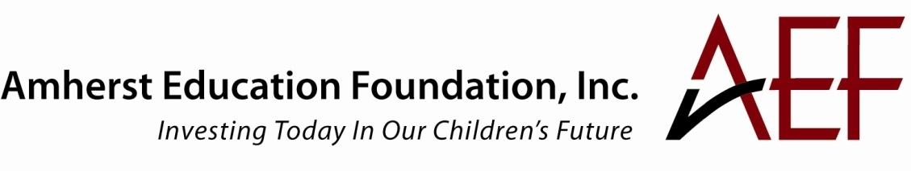

Excellence Grants
Project Period: July 1, 2018 – June 30, 2019

Proposals due Thursday, February 1, 2018

We are pleased to announce the Request for Proposals for AEF's 2018-2019 Excellence Grants Program. Teams of teachers, schools, staff, administrators and organizations affiliated with the Amherst Regional Public Schools are invited to submit applications for activities that support AEF's funding criteria, and align with the District and/or School Improvement Plans.

Funding Eligibility

- Eligible applicants are educators at the Amherst Regional Public School district, ARHS, ARMS, Crocker Farm, Fort River, Wildwood, Pelham, Shutesbury and Leverett elementary schools. Collaboration across grades, departments and schools is encouraged. External organizations can be partners in an application and receive funding through a pre-approved sub-contract with the ARPS.

- All grant proposals must be signed both by the relevant principal(s) (if building-based) prior to submission to AEF via the Superintendent’s office as described in “To Apply,” below. This is to assure that funded projects are consistent with school/district goals and to discuss any potential draw on school or district resources (for example, use of substitute teachers, demands on planning time, scheduling issues, etc.).

Funding Criteria

While each project does not need to address all criteria, AEF will give preference to those that address as many as possible. The funding criteria are below. (See application form for more detail.)
- Equity in educational access, opportunity, and/or achievement
- District-wide impact
- Focus on core educational mission
- Fostering teacher innovation/excellence
- Potential for long-term impact on student learning

Grant Amounts: AEF will fund grants between $2,500 - $15,000 each.

Deadline: Proposals are due by 5:00 PM February 1, 2018

Project Period: July 1, 2018 – June 30, 2019

Previously Funded Projects: Projects that have been funded in previous years are eligible to apply if there is a strong rationale for continued or additional funding.

To Apply: Complete proposal components listed below. Send them via email to carverl@arps.org or by mail to Superintendent’s Office, 170 Chestnut Street, Amherst, MA 01004-1825. After signing off on a proposal, the Superintendent’s office will forward it directly to AEF.

Proposal Components:
Please use the following template documents to assemble your proposal. These can be downloaded from AEF’s website, at www.amhersteducationfoundation.org.

Cover Sheet: Please complete the cover sheet with the key contact person, position, work and home contact information (in case we need to reach you over the summer), amount of funding requested, and any key partners – plus signatures of superintendent and relevant principals.

Proposal narrative: Please submit a proposal narrative, maximum 6 pages, single sided, using the Microsoft Word application document provided.

Budget: Please submit a budget for your project, using the Excel template provided.

Reporting and Monitoring Progress

1. Grantees must provide six-month and final reports to the AEF Allocations Committee describing their accomplishments and progress. Failure to provide the six-month report may impact ongoing funding.

2. The AEF Allocations Committee will assign a member to act as liaison to each grantee.

3. The AEF Allocations Committee will report on grant activities to the AEF Board at least annually.

4. The AEF Board retains the right to modify and revise these guidelines at any time.

Review Process and Timeline

The AEF Allocations Committee will screen proposals, and committee members may ask for additional information prior to making a decision regarding funding. Awards will be announced by April 2018.

February 1, 2018: Grant applications due
May 2018: Grantees announced
July 1, 2018 – June 30, 2019: Project period

For more information, visit: www.amhersteducationfoundation.org

Email questions to: grants@amhersteducationfoundation.org

